WEEK 3
Task 1: To Create Main Loop, Display Prompt, Read User Input, Handle Exit Conditions, Design Control Flow Diagram, Test Interactive Loop
- Create file
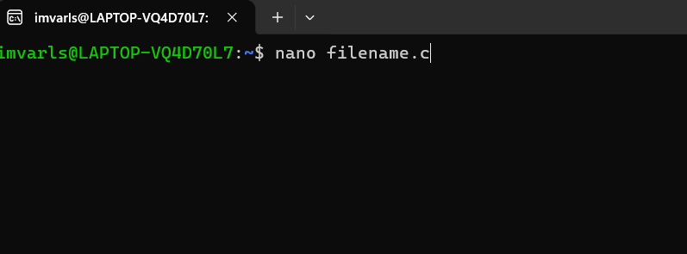

2.Program
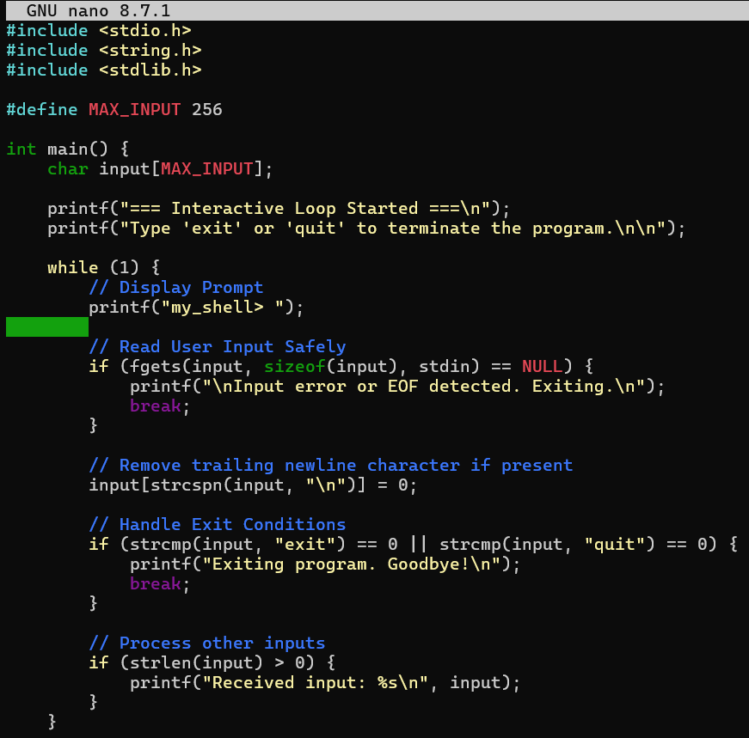

- Then for compilation write a command
gcc filename.c -o filename
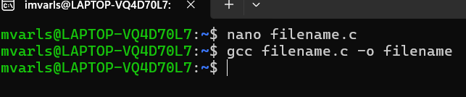

4. Then Enter./filename
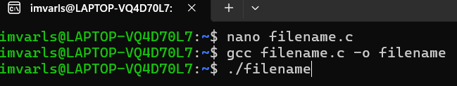

5.Output

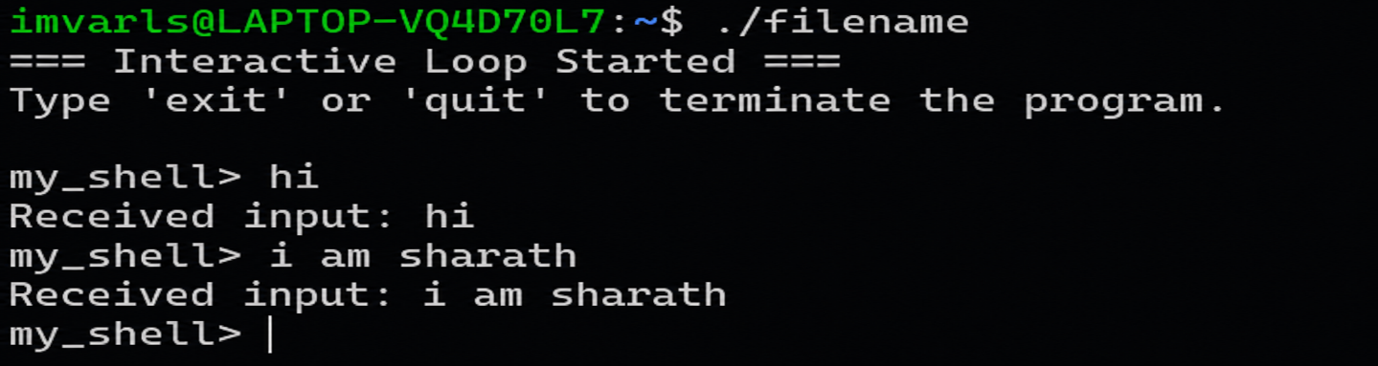

Control Flow
| Start Program |
|
v
| Display Prompt |

|
v
| Read Input |

|
v

| Exit Command? |--- Yes ---+---> [ Break / Exit ]

| No
v

| Process Input |

Task 2: Using the following system calls, copy the content from File1.txt to File2.txt.
- Open()
- Read()
- Write()
- Close()

open()
syntax: open(“ filename.txt”, modes, permissons)
Example: open(“First_Prgm.txt”, O_CREAT | O_WRONLY, 0644);

Table 1: Modes of Open system call
Flag | Purpose
O_RDONLY | Open for read only
O_WRONLY | Open for write only
O_RDWR | Open for both read and write
O_CREAT | Create file if it does not exist
O_TRUNC | Truncate (empty) an existing file
O_APPEND | Append data to the end of the file
O_EXCL | Fail if file already exists (used with O_CREAT)

read()
Syntax: read(int fd, void *buf, size_t count);
Example: read(fd, buffer, 100)
#include <stdio.h>
#include <unistd.h>
int main()
{
char buffer[100];
int n;
printf("Enter some text: ");
n = read(0, buffer, sizeof(buffer) - 1);
buffer[n] = '\0'; // Null-terminate the string
printf("You entered: %s", buffer);
return 0;
}

write()
Syntax: write(int fd, const void *buf, size_t count);
Example: write(fd, message, 11);
#include <unistd.h>
int main()
{
write(1, "Hello World\n", 12);
return 0;
}

